**SCREENSHOT OF QUE-1 ANSWER**

**SCREENSHOT OF QUE-2 ANSWER:**

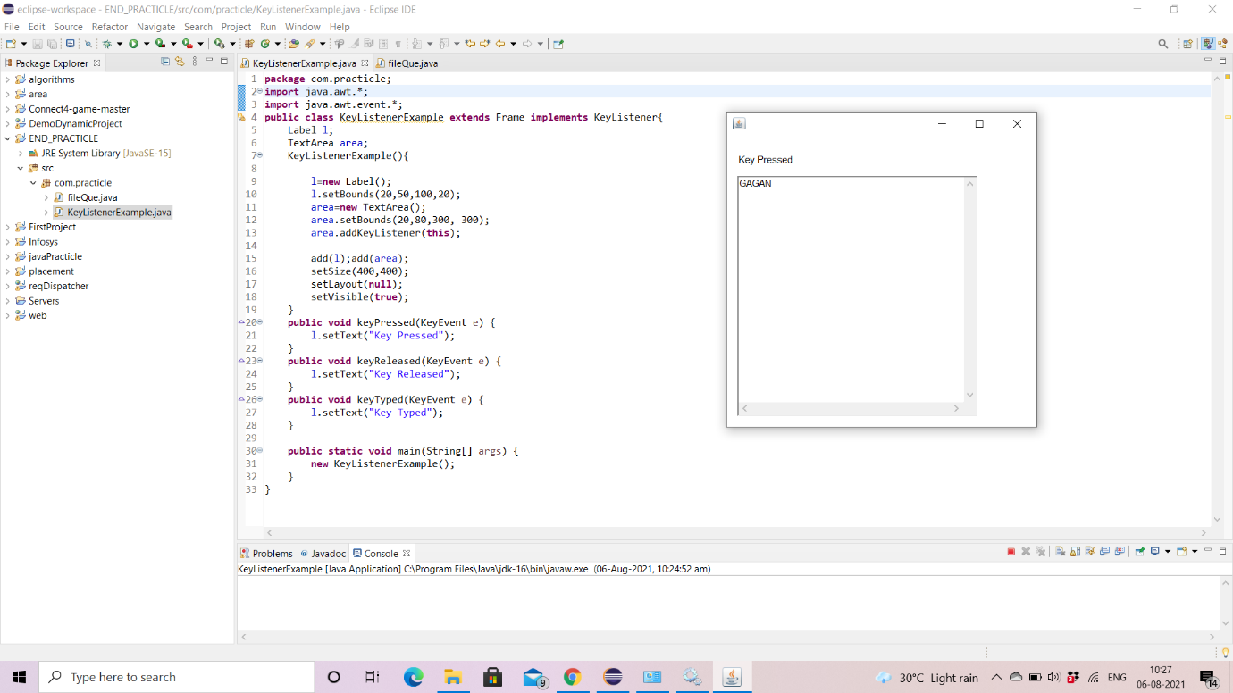

**SCREENSHOT OF QUE-3 ANSWER:**

